- IrxA
Synonyms: IrxA, irx4, Sp-IrxA
Name in the dataset: IrxA
Echinobase entry: https://www.echinobase.org/echinobase/gene/showgene.do?method=display&geneId=23182559
Protein(s): NP_001123285.1
Maternal/Zygotic: Zygotic
Working morpholino: exists according to echinobase
Expression pattern: https://journals-biologists-com.uaccess.univie.ac.at/dev/article/140/24/4881/76686/Short-range-Wnt5-signaling-initiates-specification

- Nk1
Name in the dataset: Nk1
Echinobase entry: https://www.echinobase.org/echinobase/gene/showgene.do?method=display&geneId=23077687&&sessionTabId=6312879
Protein(s): NP_999816.1
Maternal/Zygotic: Zygotic
Working morpholino: exists according to echinobase
Expression pattern: https://journals-biologists-com.uaccess.univie.ac.at/dev/article/140/24/4881/76686/Short-range-Wnt5-signaling-initiates-specification

- suPaxB
Name in the dataset: suPaxB
Synonyms: SPU_018351
Echinobase entry: https://www.echinobase.org/echinobase/gene/showgene.do?method=display&geneId=23037253
Protein(s): NP_999759
Maternal/Zygotic: Strongly maternal
Expression pattern: actually, I couldn´t find one! Supposedly it differs from Pax2/5/8 in Lytechinus and Paracentrotus, being broadly ectodermal, so is not an exact ortholog.

Hmx
Synonyms: LOC115924126, homeobox (H-6 family)
Name in the dataset: LOC115924126
Echinobase entry: https://www.echinobase.org/echinobase/gene/showgene.do?method=display&geneId=23077679&&sessionTabId=1564027
Protein(s): NP_999726.1
Coexpressed with: Wnt5, IrxA, suPaxB
Maternal/Zygotic: Maternal
Working morpholino: exists according to echinobase
Expression pattern in Strongylocentrotus purpuratus: https://anatomypubs-onlinelibrary-wiley-com.uaccess.univie.ac.at/doi/10.1002/dvdy.22514

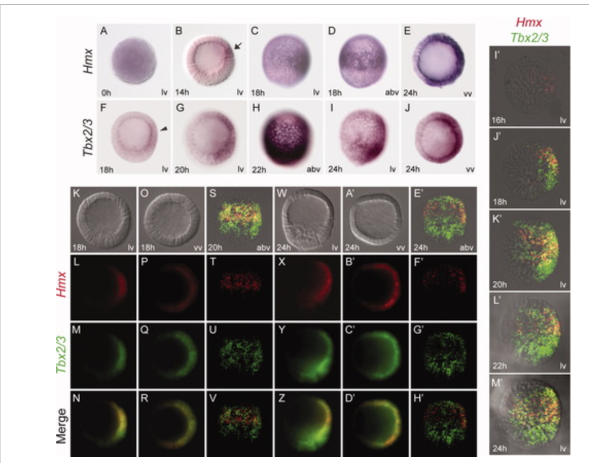

Msx
Synonyms: msh homeobox 1 (msx1), LOC110983414 , msh-like homeobox , Msx , SPU_022049
Name in the dataset: Msx
Echinobase entry: https://www.echinobase.org/echinobase/gene/showgene.do?method=display&geneId=23075660&&sessionTabId=5471103
Protein(s): NP_999778.1, XP_030841140.1
Coexpressed with: Wnt5, IrxA, suPaxB
Maternal/Zygotic: Zygotic
Working morpholino: exists according to echinobase Expression pattern in Paracentrotus lividus: https://journals.plos.org/plosgenetics/article?id=10.1371/journal.pgen.1001259#s3
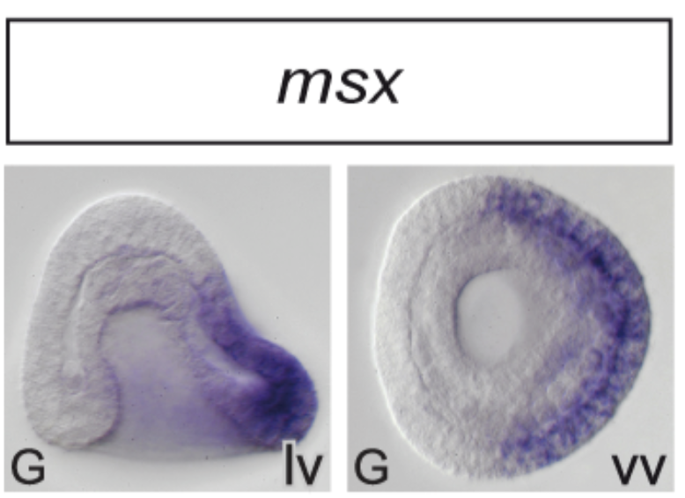

homeobox protein unc-4 homolog
Name: LOC577625, LOC115923659 (highly similar, so I collapsed them in one. Seems to exist in many co-expressed isoforms)
Synonyms: SPU_001739 , SPU_013704 , Sp-Unc4-1 , Sp-Unc4.1 (for LOC577625)
Name in the dataset: LOC577625, LOC115923659
Echinobase entries: https://www.echinobase.org/echinobase/gene/showgene.do?method=display&geneId=23023647, https://www.echinobase.org/echinobase/gene/showgene.do?method=display&geneId=23071050
Protein(s): XP_011666328.1, XP_782932.2, XP_030840660.1, XP_030840661.1, XP_030840662.1
Coexpressed with: Wnt5, IrxA, suPaxB
Maternal/Zygotic: Zygotic
Expression pattern in Paracentrotus lividus: https://journals.plos.org/plosgenetics/article?id=10.1371/journal.pgen.1001259#s3
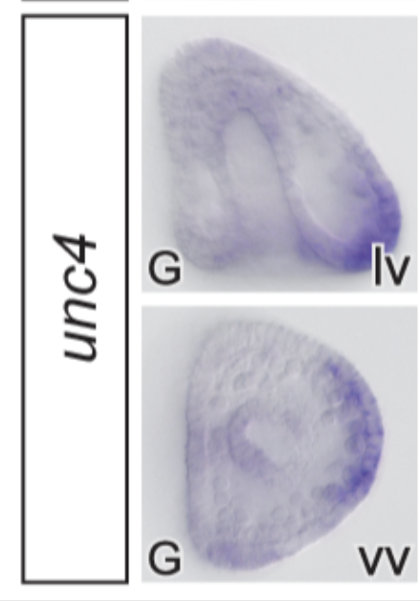

Nk2.2
Name: nkx2-2
Synonyms: LOC110977668
Name in the dataset: Nk2.2
Echinobase entry: https://www.echinobase.org/echinobase/gene/showgene.do?method=display&geneId=23149701
Protein(s): NP_001123283.1
Coexpressed with: Wnt5, IrxA
Maternal/Zygotic: Zygotic
Working morpholino: exists according to echinobase
Expression pattern in Paracentrotus lividus: https://journals.plos.org/plosgenetics/article?id=10.1371/journal.pgen.1001259#s3
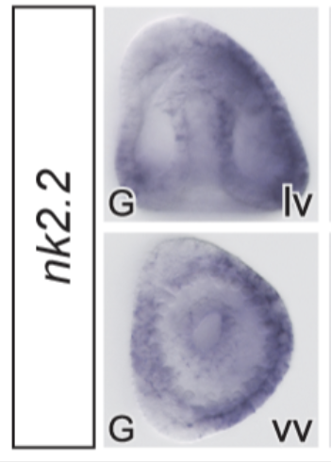

Even-skipped
Synonyms: LOC373529, evxl, even-skipped-like protein-like
Name in the dataset: eve
Echinobase entry: https://www.echinobase.org/echinobase/gene/showgene.do?method=display&geneId=23165890
Protein(s): NP_999816.1
Coexpressed with: Wnt5, Nk1
Working morpholino: exists according to echinobase
Expression in S.purpuratus: might overlap with FoxA?
https://journals.plos.org/plosbiology/article?id=10.1371/journal.pbio.1000029#s4
Expression pattern in Eucidaris tribuloides: https://pmc-ncbi-nlm-nih-gov.uaccess.univie.ac.at/articles/PMC6307887/0
